Orienteering at Fort Steilacoom Park

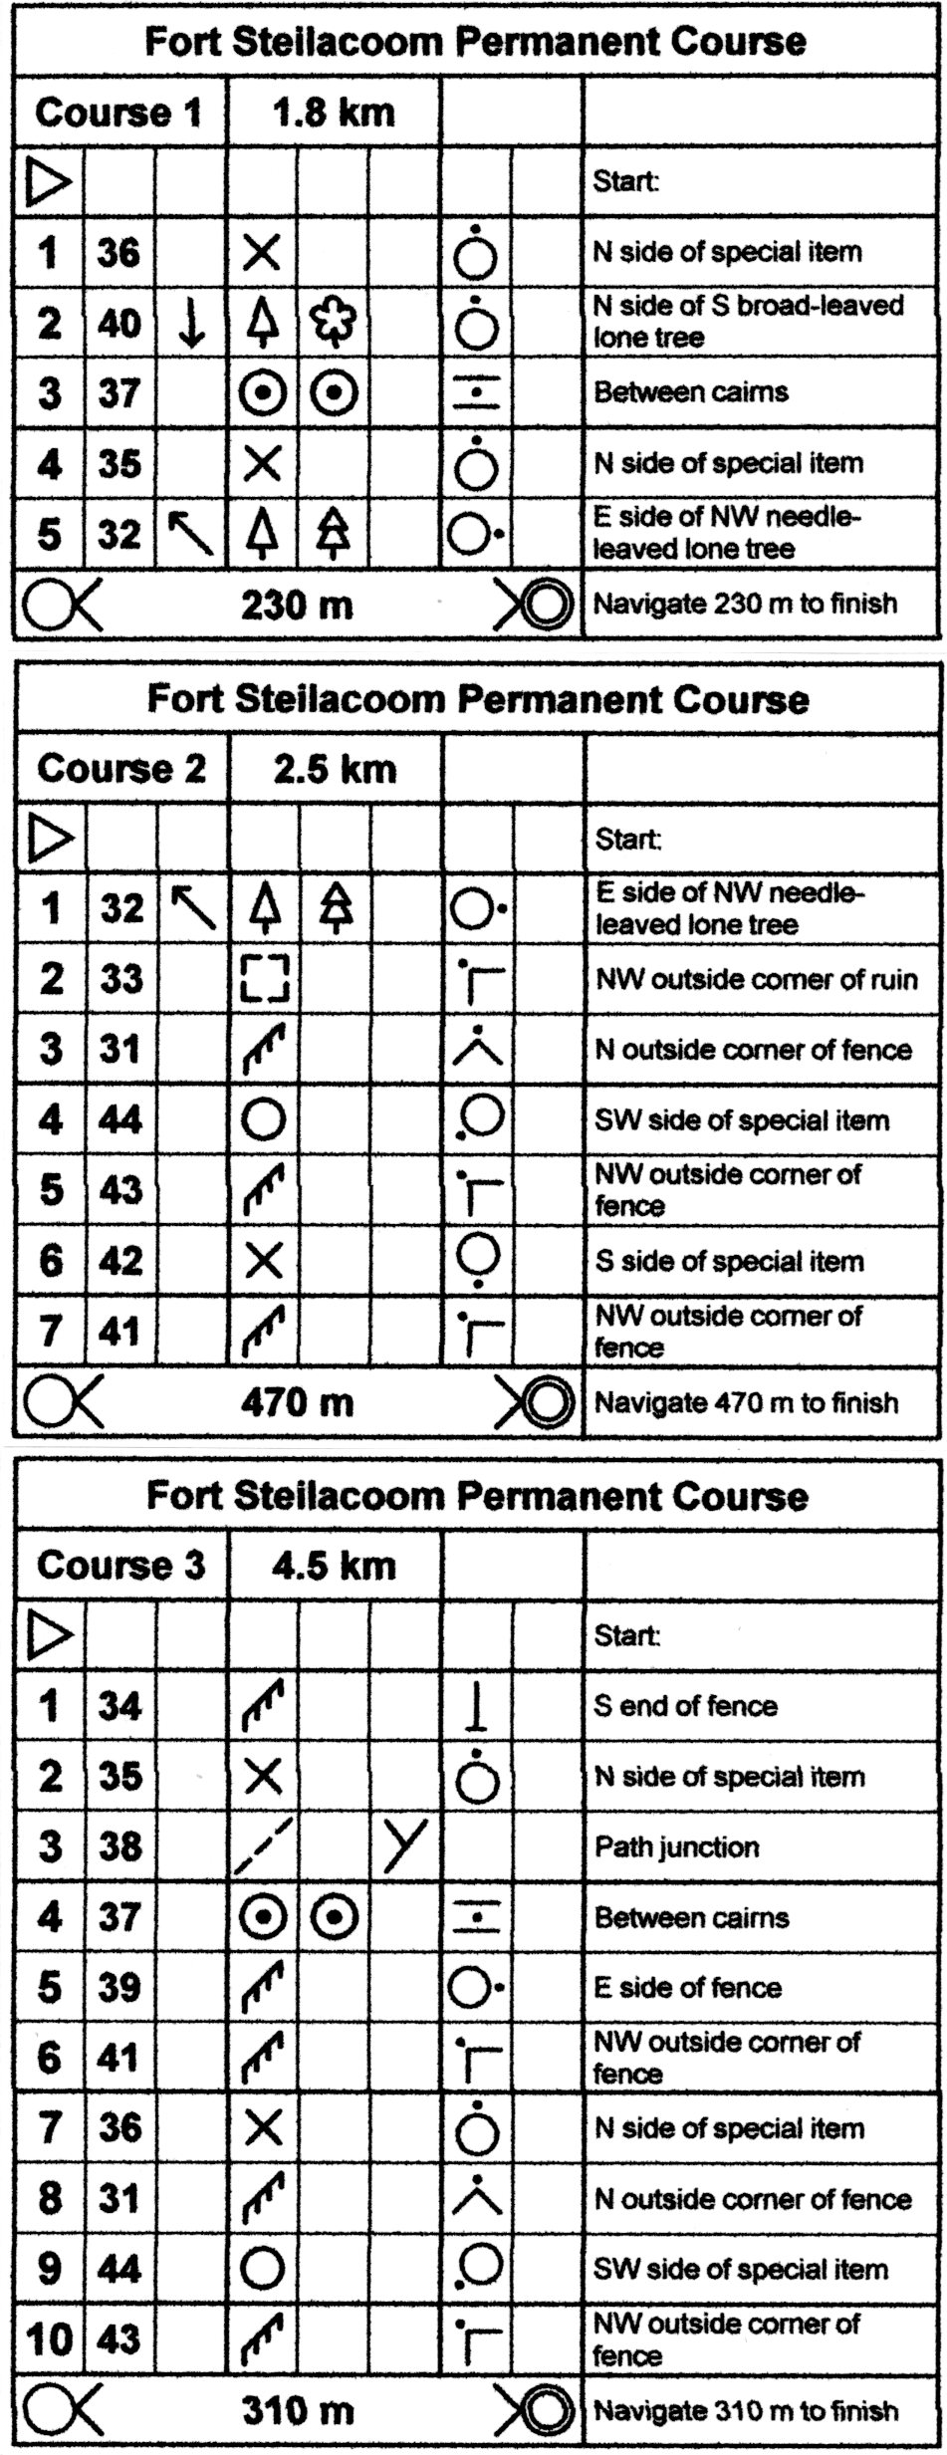
Orienteering involves the mind and the body. With the aid of a map and compass, you find your way on foot across the countryside from control to control. Your imagination and skills choose the best route. The course has painted red and white controls on 4x4 wooden posts set in the ground. You visit each control in sequence and copy the letter from the marker on a piece of paper. This verifies your completion of the course.

An orienteering map is a very detailed map. A compass is necessary to orient the map to magnetic north before starting a course and at any time during the course necessary to insure your location. The blue lines drawn vertically across the map indicate magnetic north.

Orienteering courses are usually set in a pleasant forest environment and you set your own pace. You can treat orienteering as a highly competitive race of navigational skill and physical speed or as a hike through the woods with the added fun of finding the red and white controls. Orienteering is usually an individual effort, but it is common to see groups or families hiking around an orienteering course together. Fitness and experiencing the outdoors come naturally with this sport.

Use the map and the chart to the left to find the 14 controls located in the park. You Start and Finish at the Triangle /Double Circle. There are three courses of different lengths. You should go to the numbers in order. Or you can design your own course.

Orienteering is a year round sport. Please check Cascade Orienteering Club’s website for further information about upcoming orienteering events: www/CascadeOC.org.

These permanent orienteering courses were designed and installed as a Boy Scout Eagle Award Service Project by Michael Rogers, Boy Scout Troop 696, Summit, WA.

